41.10: 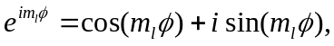 and to be periodic with period 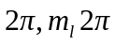 must be an integer multiple of 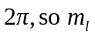 must be an integer.

